ST. JOHN’S CHURCH OF ENGLAND PRIMARY SCHOOL | CLASS: Heather | TERM: Autumn 2 | 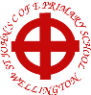
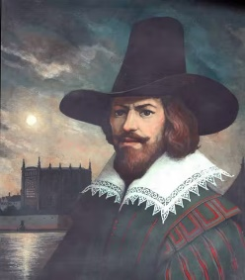 | ENGLISH:  The children will be spending some time learning stories from a selection of quality texts. We are going to start by reading some stories with a theme of conservation and creation. We will then use these stories to create our own pieces of writing.  Persuasive letters – The Journey Home  Environmental Campaign – We are Water Protectors |  | DESIGN TECHNOLOGY:  This half term we will be looking at lunchboxes and how to use the basic principles of a healthy and varied diet to prepare dishes. We will understand where food comes from and also how to package it safely.
History:  Our topic for this term is Celebrations over time. We are going to start by learning about why we celebrate Bonfire night and how it has changed over time. We are then going to learn about the history of Christmas and the traditions that we celebrate and why. | MATHS:  These are the areas of maths that we will be focussing in this half term.  - Number Concepts - Addition and subtraction  - Shape and Geometry – recognising 2D and 3D shapes |  | 
 | TOPIC/THEME:  Celebrations over Time |  | 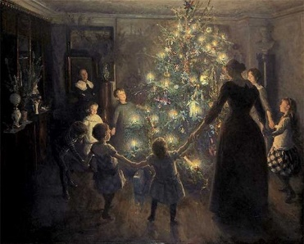
TRIPS/EXPERIENCES:

KS1 Christmas Production
 | SCIENCE:  This term in science we will be continuing to notice that animals, including humans, have offspring which grows into adults. We will also be finding out about and describing the basic needs of animals, including humans, for survival. |  | MUSIC:  Year 2 will be learning to connect sounds and music to physical movements and dance. They will also be learning and performing a Christmas Production.
PHYSICAL EDUCATION:  During our PE lessons, we will be continuing to develop multi-skills, with a particular focus on large and small ball skills, sending and receiving and striking. | COMPUTING:  This term we will looking at how different devices can be used to capture photographs. We will explore capturing, editing and improving photos. We will also learn how to use IT safely. | RELIGIOUS EDUCATION:  This term we will be continuing learning about what Jewish people believe about Torah. We will find out about Jewish daily life and worship as well as celebrations. | PHSE & SMSC:  This term we will be thinking about fairness and cooperation. We will also learn to recognise how their behaviour affects other people in both positive and negative ways.
HOMEWORK:
- Weekly Spellings and phonics.
- Daily Reading

