ST. JOHN’S CHURCH OF ENGLAND PRIMARY SCHOOL | CLASS: Heather | TERM: Autumn 1 | 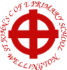
ART & DESIGN:  We are going to start the new term by using a range of materials to create our own scrap book that we will use throughout the term. We are also going to learn about the artist Giuseppe Arcimboldo, who creates works of art using fruit and vegetables! | ENGLISH:  The children will be spending some time learning stories from a selection of quality texts. We are going to start by reading some stories that are based on traditional tales that have an alternative ending. We will then use these stories to create our own pieces of writing.  Sequel Stories – The Goldilocks Project  Non-Chronological Leaflets – Wolves. |  | DESIGN TECHNOLOGY:  This half term we are finding out about fruit and vegetables and where they come from. We will learn how to chop and prepare them and then taste them in some different recipes.
GEOGRAPHY:  Our topic for this term is Wonderful Wellington. As part of this topic, we will use simple fieldwork skills to study the geography of the school grounds and the key human and physical features of its surrounding environment. | MATHS:  These are the areas of maths that we will be focussing in this half term.  - Number Concepts - Place Value  - Number Concepts - Addition and subtraction |  | 
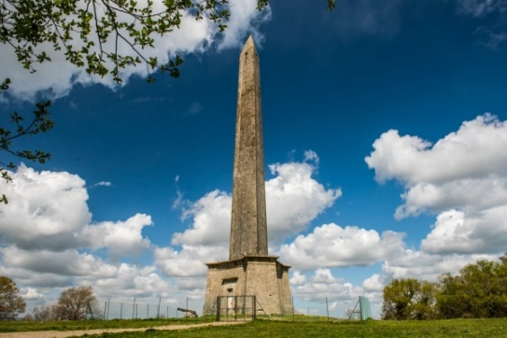 | TOPIC/THEME:  Wonderful Wellington |  | 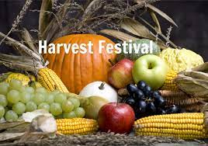
TRIPS/EXPERIENCES:

Wellington Walk
 | SCIENCE:  This term in science we will notice that animals, including humans, have offspring which grows into adults. We will also be finding out about and describing the basic needs of animals, including humans, for survival. |  | MUSIC:  Year 2 will be learning to sing a song confidently and to add actions. They will also be learning and performing a Harvest song.
PHYSICAL EDUCATION:  During our PE lessons, we will be learning multi-skills, with a particular focus on large and small ball skills, sending and receiving and striking. | COMPUTING:  This term we will exploring information technology around us. We will start by finding out what information technology is. Then we will find out about how IT is used in school and the wider world. We will also learn how to use IT safely. | RELIGIOUS EDUCATION:  This term we will be learning about what Jewish people believe about Torah. We will find out about Jewish daily life and worship as well as celebrations. | PHSE & SMSC:  This term we will be thinking about friendships and the importance of sharing as an act of kindness. We will also learn to recognise the difference between right and wrong and what is fair and unfair. We will also consider our role in our community.
HOMEWORK:
- Weekly Spellings and phonics – to be sent out later in the term.
- Daily Reading

