ST. JOHN’S CHURCH OF ENGLAND PRIMARY SCHOOL | CLASS: Otter | TERM: Autumn 1 | 
ART & DESIGN:  In our art and design lessons the children will exploring how to depict a poem through art. They will use charcoal and other media to communicate the meaning of the poem in their own way. The poem will be presented using a concertina sketchbook. | ENGLISH:  This is a three-week planning sequence using Tar Beach by Faith Ringgold in which children explore the theme of ‘freedom’ and do so by creating their own story, written as a play script, where they master their own world by flying over it, eventually writing their own version of a ‘Tar Beach’ story about their own locality or chosen place. They will also create retellings, book reviews, character descriptions and dialogue.  Spellings: Exception words address, circle, fruit, library, possess(ion), through, dessert, quarter, woman; homophones and near-homophones; possessive apostrophe with plural words |  | DESIGN & TECHNOLOGY:  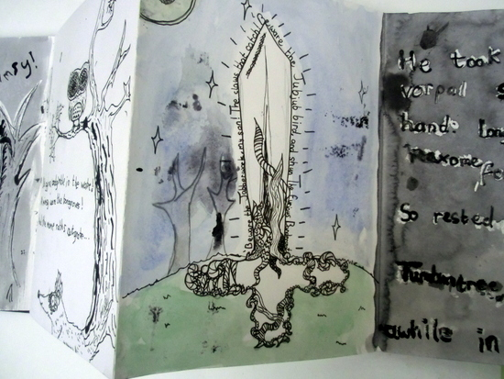
HISTORY:  Our topic for this term is all about human development from the Stone Age to the Iron Age. We shall be considering the importance of archaeological evidence and how the use of tools changed over thousands of years. | MATHS:  These are the areas of maths that we will be focussing in this half term.  Number - Place Value  Number - Addition and Subtraction. |  | GEOGRAPHY:  We will be looking at human and physical geography in our topic Somewhere To Settle.  The class will be considering the best place to build a settlement according to its access to water, shelter and food.
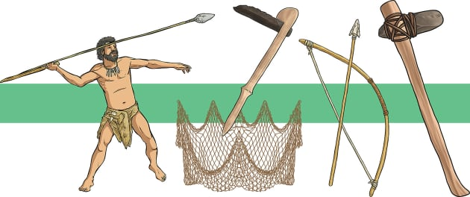 | TOPIC/THEME:  Stone Age to Iron Age |  | 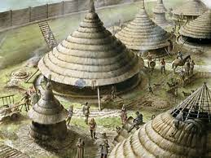
TRIPS/EXPERIENCES:

History Day in class
LANGUAGES:  In our French lessons this term, we will be learning how to greet each other, exchange names, count in 10s to 100 and name different buildings in a French town. | SCIENCE:  Our Science this term is all about exploring Sound.  We shall be discovering how sound is made and how the pitch or volume of a sounds can be altered and measured. Investigations will be conducted which will afford children the opportunity to plan, measure, record and interpret scientific information. |  | MUSIC:  Using a range of songs, including gospel, children will learn how to perform in solo and ensemble contexts with increasing accuracy, fluency, control and expression. They will also learn how to identify musical sounds and structures.
PHYSICAL EDUCATION:  Otter Class will be learning skills involved in invasion games. These skills will then be used in games such as: hockey, dodgeball and netball. | COMPUTING:  This half-term, we will learn how the internet works and ways in which information is sorted and shared safely. | RELIGIOUS EDUCATION:  This term we will be considering the principles and values of Hinduism. | PSHE:  This term we will be thinking about being safe online.
HOMEWORK:
- Weekly Spellings, Multiplication Tables
- Daily Reading
- 55 Club

