ST. JOHN’S CHURCH OF ENGLAND PRIMARY SCHOOL | CLASS: Otter | TERM: Spring 1 | 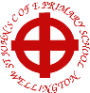
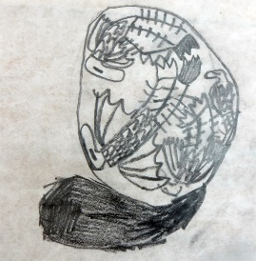  ART & DESIGN:  Our theme for this half-term is Dragons and Birds in Eggs. This programme of study shares a simple but engaging exercise which combines drawing, printmaking and collage. | ENGLISH:  Our focus book for writing tasks this half-term is ‘FArTHER’ by Grahame Baker Smith. We introduce the concept of dreams and how important they are in our lives and continue exploring the text using story maps and by writing a set of instructions on flying machines. The class finishes the 3-week topic by writing a longer adventure story.  Our reading book is ‘The Story of Flight’, written by Jakob Whitfields – a beautifully illustrated history of the iconic flying machines that have helped us soar through the skies.  Spellings: Exception words – complete, disappear, experiment, increase, learn, often, promise, regular, thought, different. Common prefixes and suffixes. |  | DESIGN & TECHNOLOGY:  The Otters will be exploring different kinds of fastenings that are used in the design of clothing and other textile-based products.  They will then design and then make a textile pencil case, complete with method of fastening.
HISTORY:  Our local history study takes in the history and geography of our home town including its industrial past and the Wellington monument. | MATHS:  These are the areas of maths that we will be focussing in this half term.  Number – Multiplication and division strategies  Measure – Area of 2d shapes  Fractions – adding, subtracting and equivalence |  | GEOGRAPHY:  We will be looking at human and physical geography in relation to our local history topic on Wellington. We will also be learning how to read and create maps.
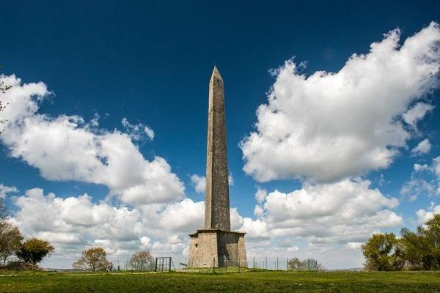 | TOPIC/THEME:  Wonderful Wellington |  | 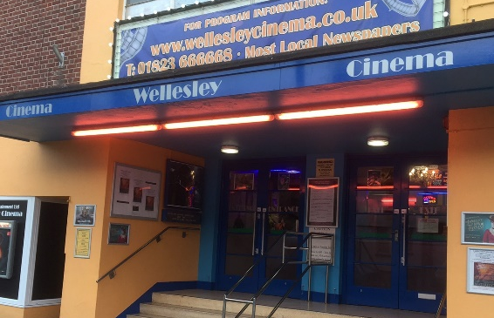
TRIPS/EXPERIENCES:

Field Trip around Wellington/Visit Museum
LANGUAGES:  In our French lessons this term, we will revise greetings and counting to 100, then move onto learning words linked to transport. We shall be increasing the difficulty of our sentences and learning how to converse together. | SCIENCE:  Our Science topic this term is all about States of Matter – solid, liquid and gases – and how these states can change through the processes of boiling, melting, condensation, evaporation and freezing. We will be making close observations, devising investigations and making scientific conclusions from our results. |  | MUSIC:  Samba is the focus for the rest of the year as Mr Gareth Clarke from Somerset Music will be teaching the Otters how to play drums, claves, agogos etc in order to bring the sounds of South America to Wellington!
PHYSICAL EDUCATION:  Otter Class will be focusing on gymnastics and dance with Mr Parsons who will help them to improve their co-ordination skills, sequencing and ability to move in time with the music and with a partner. | COMPUTING:  Children will develop their understanding of how digital images can be changed and edited, and how they can then be resaved and reused. They will consider the impact that editing images can have, and evaluate their choices. | RELIGIOUS EDUCATION:  Christianity is the focus this half-term with a particular focus on Lent, the Easter Story and what salvation means to Christians. | PSHE:  This term we will be learning about healthy eating. We will be learning about different food groups and how to plan a balanced meal which will feed our bodies and minds.
HOMEWORK:
- Weekly Spellings, Multiplication Tables
- Daily Reading
- 55 Club

