ST. JOHN’S CHURCH OF ENGLAND PRIMARY SCHOOL | CLASS: Otter | TERM: Spring 2 | 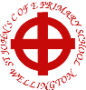
ART & DESIGN:  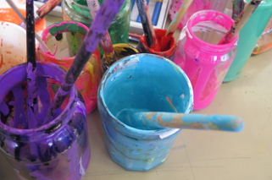  Our theme for this half-term is Drawing with Scissors.  We shall be mixing colours and replicating elements of famous pictures with bright shapes cut out from our own colour-mixed paper. | 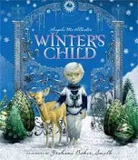  ENGLISH:  Our focus book for writing tasks this half-term is ‘Winter’s Child’ by Alison McAllister. Children will really enjoy this fantasy story and will have the opportunity to write new episodes. They will practice how to write interesting and well-punctuated dialogue and how to make their settings magical.  Our reading book is ‘The Firework Maker’s Daughter’, written by Philip Pullman. Lila knows what she wants: she doesn’t just want to be a Firework-Maker’s Daughter; she dreams of being a Firework-Maker herself!  Spellings: Common exception words, including: answer, bicycle, centre, guide, knowledge, learn, questions, suppose, therefore, minute, appear, consider, describe, height, length, pressure, straight, weight, certain, purpose, breathe  -ous adjectival suffix and adding suffixes to stressed and unstressed syllables |  | DESIGN & TECHNOLOGY:  The Otters will be continuing to practise their sewing skills as they attempt to make a book protector with a fastening.    Sewing skills will include: threading a needle, securing a thread, running stitch, back stitch and button work.
HISTORY:  Our local history study takes in the history and geography of our home town including its industrial past and the Wellington monument. | MATHS:  These are the areas of maths that we will be focussing in this half term.  Fractions – adding, subtracting and equivalence  Revision of multiplication and division strategies, including finding area and perimeter  Decimals – including multiplying and dividing by 10, 100 and 1000 |  | GEOGRAPHY:  We will be looking at human and physical geography in relation to our local history topic on Wellington. We will also be learning how to read and create maps.
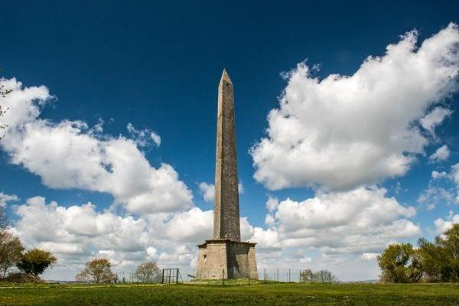 | TOPIC/THEME:  Wonderful Wellington |  | 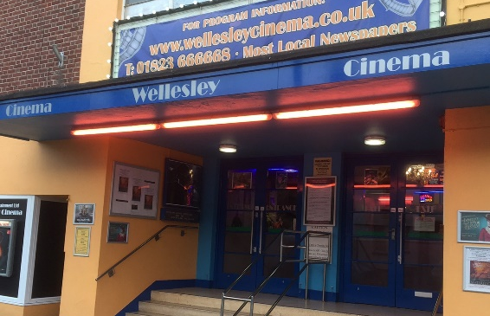
TRIPS/EXPERIENCES:

Field Trip around Wellington/Visit Museum
LANGUAGES:  In our French lessons this term, we be exploring other countries. Sentences and grammar will be extended so children can describe Where In The World French is spoken and certain animals are found. | SCIENCE:  Our Science topic this term is Electricity. The children will learn how electricity flows through a current; how to make circuits; and how to test the conductivity and of a range of materials. They will learn to identify the separate elements of a circuit and how to record these in scientific symbols. They will be predicting results, devising experiments and making conclusions. |  | MUSIC:  Samba is the focus for the rest of the year as Mr Gareth Clarke from Somerset Music will be teaching the Otters how to play drums, claves, agogos etc in order to bring the sounds of South America to Wellington!
PHYSICAL EDUCATION:  Otter Class will be focusing on net and wall games with Mr Parsons who will help them to become more strategic in their play | COMPUTING:  Children will develop their understanding of how information, including numbers, are collected, stored and interpreted through computers through data-logging. | RELIGIOUS EDUCATION:  Christianity is the focus this half-term with a particular focus on the meaning of Salvation and the key elements of the Easter Story and how Easter is celebrated in church. | PSHE:  This term we will be learning about managing emotions, helping others to find answers to problems and how to share opinions in a polite and respectful manner.
HOMEWORK:
- Weekly Spellings, Multiplication Tables
- Daily Reading
- 55 Club

