ST. JOHN’S CHURCH OF ENGLAND PRIMARY SCHOOL | CLASS: Otter | TERM: Summer 1 | 
ART & DESIGN:  Our theme for this half-term is Drawing Nests and Building Nests.  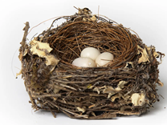  We shall be using graphite, clay and natural materials to create our own 2 and 3D nests showing clear texture, form and detail. | ENGLISH:  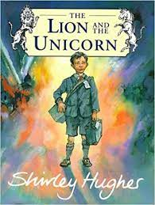  Our focus book for writing tasks this half-term is ‘The Lion And The Unicorn’ by Sheila Hughes. This story is set in World War II and will enable the children to explore historical themes. They will also write letters, diaries, character and setting descriptions and non-chronological reports.  Our reading book is ‘Tamarind and the Star of Ishta’ written by  Jasbinder Bilan. A powerful story of loss and identity, home and family, Tamarind and the Star of Ishta weaves a family mystery together with adventure and wonder.  Spellings: Common exception words, including: believe, build, actually, occasionally, particularly, separate, eight, although  Words ending in -que and -gue; negative prefixes including – dis, mis, il, im and ir; words including dge, ei and eigh. |  | DESIGN & TECHNOLOGY:  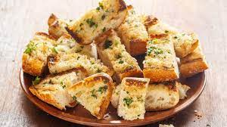  The Otters will be continuing to practise their sewing skills as they attempt to make a bookmark. Sewing skills will include: threading a needle, securing a thread, running stitch, back stitch and button work.  We are also planning to make our own garlic bread using the ‘crop’ we have grown at school as part of our science experiment.
HISTORY:  We shall continue with elements of our local history study which takes in the history and geography of our home town including its industrial past and the Wellington monument. | MATHS:  These are the areas of maths that we will be focussing in this half term.  Fractions and decimals – adding, subtracting and equivalence  Measure – money and time  Statistics – reading and interpreting different graphs including bar, line and pictogram |  | GEOGRAPHY:  We will studying the city of Sheffield as a contrasting UK location to Wellington. We will be looking a physical and human geography and using a range of maps and tourist information
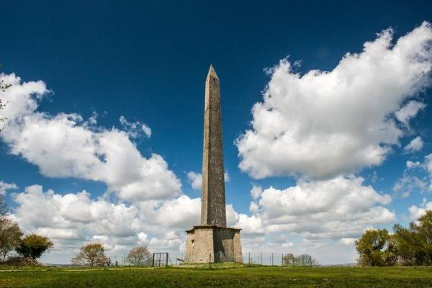 | TOPIC/THEME:  What’s It Like In Sheffield? |  | 
TRIPS/EXPERIENCES:

Field Trip around Wellington/Visit Church
LANGUAGES:  In our French lessons this term, we will be learning how to tell the time and how to describe the different activities we do in the course of a week. | SCIENCE:  Our Science topic this term is the Animal Kingdom, including Humans. We shall be studying the different elements of the digestive system; learning about different kinds of teeth and their functions; and how food chains fit together. Running alongside this topic is a reminder of how we can look after our bodies by eating healthily, keeping clean and regularly exercising. |  | MUSIC:  Samba is the focus for the rest of the year as Mr Gareth Clarke from Somerset Music will be teaching the Otters how to play drums, claves, agogos etc in order to bring the sounds of South America to Wellington!
PHYSICAL EDUCATION:  Otter Class will be focusing on athletic skills with Mr Parsons including running, throwing and jumping disciplines. | COMPUTING:  Children will be developing their programming skills using repeated shapes. | RELIGIOUS EDUCATION:  Christianity is the focus this half-term with a particular focus on the meaning of Agape in the context of the Bible. | PSHE:  This term we will be learning to plan steps towards a future and how to celebrate the good things that make us all special.
HOMEWORK:
- Weekly Spellings, Multiplication Tables
- Daily Reading
- 55 Club

