ST. JOHN’S CHURCH OF ENGLAND PRIMARY SCHOOL | CLASS: Otter | TERM: Summer 2 | 
ART & DESIGN:  Our theme for this half-term is a continuation Drawing Nests and Building Nests.  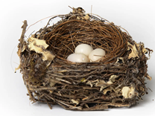  We shall also be trying out lots of different mark making to create texture, shading and a range of tones in our drawing. | ENGLISH:  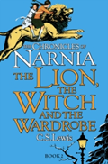  Our focus book for writing tasks this half-term is ‘The Lion, The Witch and The Wardrobe’ by CS Lewis. This is a classic story of friendship, overcoming challenges and the magic of another world. This time we will be focusing on creating poetry related to this book and also writing as one of the key characters in the book.  Our reading book will be ‘Pride: The Story of Harvey Milk and The Rainbow Flag’ which is a celebration of diversity and is a modern tale with plenty of discussion points.  Spellings: Common exception words, including: Certain, continue, experience, forwards, guard, peculiar, surprise, various, strange.  Words ending beginning with the prefixes: anti, sub, il and ire |  | DESIGN & TECHNOLOGY:  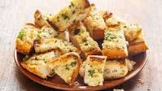  The Otters will be devising, altering and following a recipe for garlic bread using the very garlic that was planted earlier in the year as a result of our science investigation
HISTORY:  We shall be looking at the history of the city of Sheffield, known for its industrial past. We shall also be researching the reasons why Sheffield has been considered to be an important city. | MATHS:  These are the areas of maths that we will be focussing in this half term.  Decimals – adding, subtracting and equivalence  Written strategies for all four operations  Properties of Shape  Position and Direction |  | GEOGRAPHY:  We will be continuing our study of the city of Sheffield as a contrasting UK location to Wellington and then moving on to look at global mapping, including time zones, climates and co-ordinates.
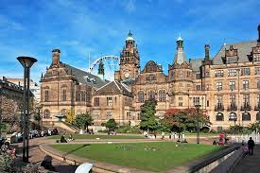 | TOPIC/THEME:  What’s It Like In Sheffield? |  | 
TRIPS/EXPERIENCES:

Trip to Exmoor Zoo
LANGUAGES:  In our French lessons this half-term, we will be learning how to describe the weather, naming the seasons of the year and talking about our different hobbies and what we like to do in our spare time. | SCIENCE:  Our Science topic this term is a continuation of our focus on Living Things. We will be learning how to group species according to their characteristics; how to conduct a local habitat survey, looking at the positive and negative changes to our local environment; and considering how species become endangered and how we can combat this through research. |  | MUSIC:  Samba is the focus for the rest of the year as Mr Gareth Clarke from Somerset Music will be teaching the Otters how to play drums, claves, agogos etc in order to bring the sounds of South America to Wellington!
PHYSICAL EDUCATION:  Otter Class will be focusing on athletic skills with Mr Parsons including running, throwing and jumping disciplines. | COMPUTING:  Children will be developing their programming skills using the software programme Logo; they will also be debugging errors. | RELIGIOUS EDUCATION:  Christianity is the focus this half-term with a particular focus on the meaning of Agape in the context of our community. | PSHE:  This term we will be learning how to manage bullying behaviour and how to foster good relationships with a range of people
HOMEWORK:
- Weekly Spellings, Multiplication Tables
- Daily Reading
- 55 Club

