ST. JOHN’S CHURCH OF ENGLAND PRIMARY SCHOOL | CLASS: Otter | TERM: Autumn 1 | 
ART & DESIGN:  In our art and design lessons the children will exploring how the work of illustrators Cressida Cowell and Quentin Blake in order to research mark making. They will then illustrative parts of Lewis Carroll’s famous poem ‘Jabberwocky’ using their imaginations to work with charcoal and other media. | ENGLISH:  This is a three-week planning sequence using Tar Beach by Faith Ringgold in which children explore the theme of ‘freedom’ and do so by creating their own story, written as a play script, where they master their own world by flying over it, eventually writing their own version of a ‘Tar Beach’ story about their own locality or chosen place. They will also create retellings, book reviews, character descriptions and dialogue.  Spellings: Exception words address, circle, fruit, library, possess(ion), through, dessert, quarter, woman; homophones and near-homophones; possessive apostrophe with plural words |  | DESIGN & TECHNOLOGY:  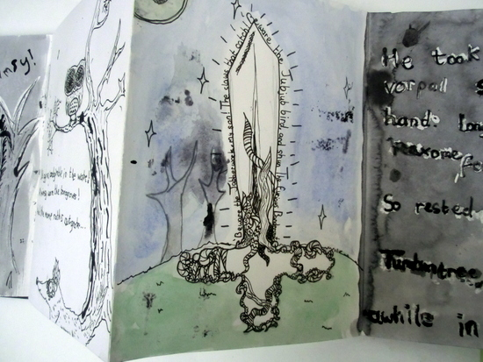
HISTORY:  Our topic for this term is all about the Romans and their invasion of Britain, The children will explore the evidence of Roman settlement and the reasons why Britain was so coveted by the Romans. | MATHS:  These are the areas of maths that we will be focussing in this half term.  Number - Place Value  Number - Addition and Subtraction. |  | GEOGRAPHY:  With links to our history topic, the children will be looking at the sites on the east coast of the UK where the Romans landed. There will also be an exploration of settlement names that reveal Roman origination.
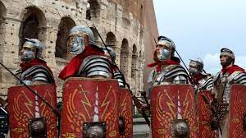 | TOPIC/THEME:  The Roman Invasion of Britain |  | 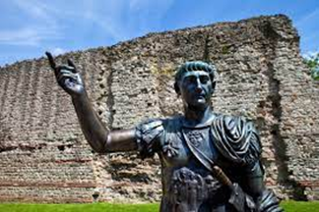
TRIPS/EXPERIENCES:

Visit by a Roman Centurion
LANGUAGES:  In our French lessons this term, we will be learnin how to greet each other, exchange names, count in 10s to 100 and name different buildings in a French town. | SCIENCE:  Our Science this term is all about exploring Sound.  We shall be discovering how sound is made and how the pitch or volume of a sounds can be altered and measured. Investigations will be conducted which will afford children the opportunity to plan, measure, record and interpret scientific information. |  | MUSIC:  The children will be learning to play the trumpet with Mrs Wordley on a Wednesday and refining their singing skills with Miss Clarke in the classroom in preparation for our Harvest Festival.
PHYSICAL EDUCATION:  Otter Class will be learning skills involved in invasion games. These skills will then be used in games such as: hockey, dodgeball and netball. | COMPUTING:  This half-term, we will learn how the internet works and ways in which information is sorted and shared safely. | RELIGIOUS EDUCATION:  This term we will be considering the principles and values of Hinduism. | PSHE:  This term learning how computers ‘talk’ to each other throw a network and using routers. We will also spend time focusing on important internet safety,.
HOMEWORK:
- Weekly Spellings, Multiplication Tables, 55 Club and Daily Reading

