ST. JOHN’S CHURCH OF ENGLAND PRIMARY SCHOOL | CLASS: Otter | TERM: Spring 1 | 
DESIGN & TECHNOLOGY:    Our theme for this half-term is Battery-operated Lights. The children will combine a knowledge of electrical circuits with design skills in the design and creation of their own switch-connected lighting system. | ENGLISH:  Our focus book for writing tasks this half-term is ‘Varmints’ by Helen Ward and Mark Craste. This is a wonderful illustrated book that explores the themes of environment, sounds, imagination, freedom and solitude. It was certainly get the Otters thinking.  Our reading book is ‘Zombierella’, written by Joseph Coelho – a modern and slightly spooky take on the traditional tale ‘Cinderella’. It is freaky, fun and full of poetic phrasing and character.  Spellings: Exception words – decide, guide, important, learn, natural, notice, possible, group, different, interesting and words ending in the suffix – tion. |  | ART & DESIGN:  Storytelling Through Drawing    We shall be exploring how artists create sequenced drawings to share and tell stories. Accordion books or comic strips will be recreated to retell poetry or prose through drawing.
HISTORY:  In Otter Class we shall be continuing our study of the Romans, looking particularly at the influence of these invaders on lives of the native Britons. As always, in history, evidence in key and we shall be emphasising the importance of this. | MATHS:  These are the areas of maths that we will be focussing in this half term.  Measure – Perimeter and other forms of measurement  Number – Multiplication and division strategies |  | GEOGRAPHY:  We will be looking at human and physical geography in our topic Somewhere To Settle.  The class will be considering the best place to build a settlement according to its access to water, shelter and food.
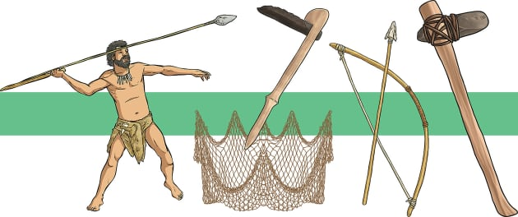 | TOPIC/THEME:  Everyday French |  | 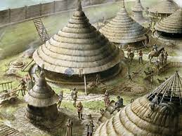
TRIPS/EXPERIENCES:

French Day in class
LANGUAGES:  In our French lessons this term, we will be learning how to speak about colour, countries around the world and continue to build up a repertoire of conversational French using greetings and basic questions and answers. | SCIENCE:  Our Science this term is all about exploring Sound.  We shall be discovering how sound is made and how the pitch or volume of a sounds can be altered and measured. Investigations will be conducted which will afford children the opportunity to plan, measure, record and interpret scientific information. |  | MUSIC:  Focusing on a football song called, ‘My Fantasy Football Team’ the children will be learning notation rhythms and how to compose and perform repeated phrases to form a whole-class ensemble piece.
PHYSICAL EDUCATION:  Otter Class will be learning skills involved in team games, including those that involve invasion of the opposition’s territory eg. hockey, dodgeball and netball. | COMPUTING:  This half-term, we will learn how to complete some audio editing which should match-up with our science topic on sound. | RELIGIOUS EDUCATION:  This term we will be considering the principles and values of Hinduism. | PSHE:  This term we will be thinking about managing feelings and building resilience.
HOMEWORK:
- Weekly Spellings, Multiplication Tables
- Daily Reading
- 55 Club

